**Using****sections in Word**

Word uses section breaks to specify parts of a document that have different page orientation, columns, or headers and footers. Section breaks allow the user to specify where the different formatting will begin and end. You might use section breaks in the following circumstances:

|  |  |
| --- | --- |
|  | **Different headers and footers**. If the document you are working on needs to have different headers and footers on various pages, you would use section breaks to achieve this. |
|  | **Different numbering schemes**. If you are working in a document where the Table of Contents needs lower case Roman numerals, the contract needs Arabic numerals, and the Appendices need alphabetic numerals, you can achieve all of these with section breaks. |
|  | **Different paper sizes.** If you want a document to contain one portrait page and one landscape page, you'll need a section break between the pages. |
|  | **Different margins**. If the first page of a letter needs a two-inch margin, and the following pages need a different margin, you'll need a section break in the document. |
|  | **Columns**. You can use Word's newspaper column feature in the middle of a page, and place section breaks before and after the multiple columns. If you have text prepared and put it into a column format, word will automatically put in the section breaks. |
|  | **Document protection**. You can apply different protection levels to different sections in Word. This lets you allow editing in some sections and not others.   |  | | --- | |  |   The Break dialog for Word 2007 and Word 2010, accessible from the Page Layout Tab |

**How to view a Section Break**

You can see the section breaks in your document in many views, but in draft view they are easiest to recognize. Once you insert the section break a double dotted line appears from one side of your document to the other.

You can also view them in Print Layout view using the Show All button on the Home tab. Pillcrow - show all button in Microsoft Word

**EXERCISE 1: Inserting a section break**

1. Open a blank document.
2. Change your document view to Draft.
3. Type the following: **Title Page**.
4. Now insert a new page section break: Page Layout (tab) > Break (right side of page setup group).
5. Choose Next Page Section Break.
6. Type **Table of Contents**.
7. Insert a new page section break: Page Layout (tab) > Break (right side of page setup group).
8. Choose Next Page Section Break.
9. Type **Main document**.

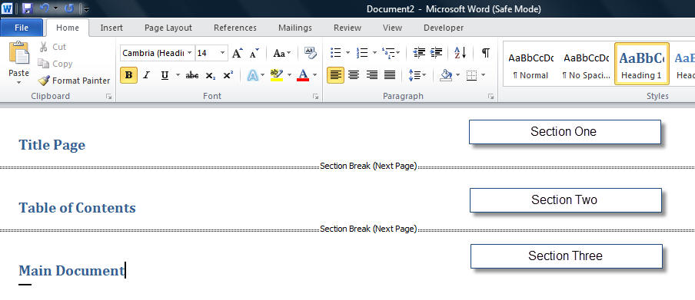

*View of exercise document in Word 2010. (2007 will have the Pizza button*Sections Office 2007 2010 Office Button Pizza Button*instead of the File tab)*

View your document in Print Layout. You now have three sections. Switch between Draft and Page Layout views in this document to see how the section break appearance differs. (We will be using this document in the next exercise.)*Note: To make it easier to see the example, I applied the Heading 1*[*style*](http://www.addbalance.com/usersguide/styles.htm)*to each of the lines.*

**Change Page Formatting in a Specific Section**

To better understand how sections work, think of your document as a book with different chapters, and each chapter starts with page number one.

In the last exercise we created a document with three separate sections. We are now able to apply unique formatting to each section of the document. The exercise that follows will help you change the margins and the page layout in the document using section breaks.

**EXERCISE 2: Change Page Formats in Sections**

1. Use the document you created in the last exercise.
2. Press CTRL+END to move to the end of your document. You should be in Section 3.
3. Choose Page Layout (tab) >click Orientation.
4. In the Orientation area, select Landscape.
5. By default, this change will apply only to the section you are in.
6. The last page should now be landscape and the rest of the document should still be portrait.
7. Press CTRL+HOME to go to the top of the document.
8. Choose Page Layout (tab) and click on the Page setup dialog (arrow in bottom right corner of group)
9. Click on the Layout tab of this dialog box
10. In the center under "Page" is a drop-down for Vertical Alignment
11. In this Vertical Alignment section, select Center from the drop-down list.
12. Click OK. Your "TITLE PAGE" text should now be centered vertically.
13. Try changing margins in a specific section. (Page Layout tab)

**Headers and Footers**

A header or footer is text or other information such as graphics that is stored at the top or bottom of the page throughout your document. You can use the same header and footer throughout a document or change the header and footer for part of the document. For example, you can use your corporate logo in the first-page header, and then include the document's file name in the header for subsequent pages.

Word 2007 and 2010 put the controls for the Headers and Footers under the Insert tab.

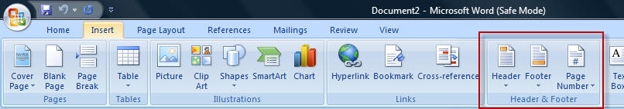

*Insert tab in Word 2007*

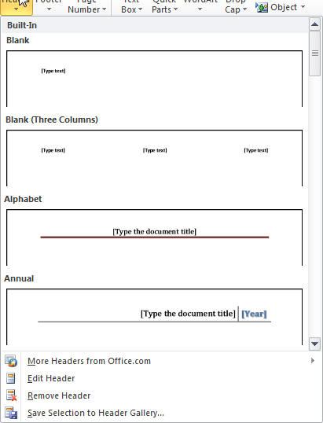

Header gallery                                        Footer Gallery

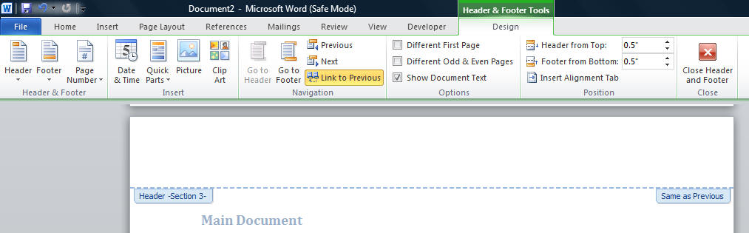

*View of the Header and Footer Tools when in edit Header mode*

**Note**: If you Edit the Header or Footer rather than insert one of the Building Blocks the formatting starts with a blank area using the Header and Footer [paragraph styles](http://www.addbalance.com/usersguide/styles.htm). For some reason, the Building Block headers and footers directly format rather than use these styles. The basic style has tab settings for a Center tab at 3.25" and a Right tab at 6.5". These are based on 1" margins. The Building Block headers and footers tend to use Center and Right justifications rather than the tab settings. You can easily view these settings by clicking the Ruler box under the View tab.

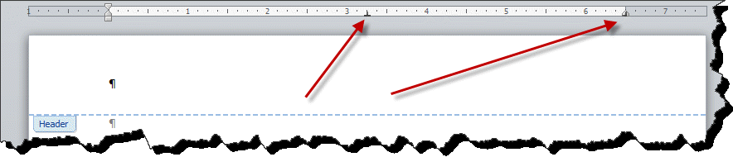

If you want to change the appearance of all of the headers and footers in a document, modify the Header and Footer Styles. Your author tends to have headers and footers extend outside the page margins by half an inch and be in *Italic*using a different font. I use sanserif fonts for headers and footers and serif fonts for body text. This is intended to emphasize that the headers and footers are outside of the body, a textual frame for the page. It is intended that they provide information without interrupting the reader's flow from page to page.

**EXERCISE 3: Use the Header/Footer Toolbar**

1. Choose Insert (tab) > Header.
2. Pick the Edit Header choice.
3. Your insertion point should be in the Header
4. Press Ctrl-R to align to the right side of the Header.
5. Type **DRAFT Rough Outline**.
6. Click the Go to Footer button to move to the footer.
7. By default in the Footer [style](http://www.addbalance.com/usersguide/styles.htm) there are already Center and Right Tabs set.
8. Press TAB once to move to the center of the Footer.
9. Click the Page Number button and pick the "Current Position" option - Plain Number.

|  |  |
| --- | --- |
| Note | **Note**  If you want to add the word "Page" or dashes on either side of the number, you can type the information before inserting the page number. |

1. Press TAB once to move to the right side of the Footer.
2. Click the Date & Time button to insert the date. You can select a date format.

|  |  |
| --- | --- |
|  | **Warning**  If you check the Update Automatically will insert an updating date that will change to the current date each time you print. (In previous versions this was the default.) |

1. Click Close Header & Footer on the Header and Footer tools bar.
2. Switch to Print Layout to view your newly added Header and Footer.

|  |  |
| --- | --- |
| Note | ***Headers and Footers in Print Layout.***  Headers and Footers will appear faded or gray in Print Layout. They will print with full strength colors.  If instead of seeing a Header or Footer you see a thin gray line between pages and it looks like you have no top or bottom margins, you are set to not view space between pages.http://www.addbalance.com/usersguide/images/SectionWS1.jpg  If you put your mouse pointer over that line it will change as shown to the right. If you click once, you'll see the tool-tip shown here. Double-clicking will show you the headers and footers with space between pages as shown below:  http://www.addbalance.com/usersguide/images/SectionWS2.jpgThis is what you will usually want when in Print Layout.  You can also choose this under Options > Display (under the File tab in Word 2010 and under the Office Button Sections Office 2007 2010 Office Button Pizza Button in Word 2007.*(below)*  Page numbers Sections Microsoft Word White Space |

|  |  |
| --- | --- |
| Note | AutoText in the Header/Footer Toolbar.  You can access Quick Parts including AutoText in the Header Footer Tools bar. Unfortunately, unlike in previous versions, it is not set up well for finding what you want. If you know the name of an entry, you can type that name and press the F3 key to insert it. |

**Different First Page**

There are times when you do not want the page number on the first page of your document. In WordPerfect, this was called Suppress. In Word, the feature is called Different First Page. This means you are still able to put information into the Header or Footer but it will not affect the rest of the Headers and Footers in the document.

|  |  |
| --- | --- |
| Note | **Note** This is frequently used when the firm logo or partner's names appear on the first page of a letter. |

Word 2007 and 2010 put the controls for page numbering under the Insert tab. Different options are presented and you can also get a dialog box using the Format Page Numbers button.

**EXERCISE 4: Turn on Different First Page**

1. Open the document from the last exercise.
2. Double-click the Header in your document. This will access the header and footer area and activate the Header and Footer Tools contextual tab.

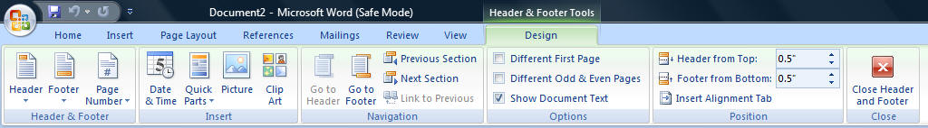

1. Check Different First Page.
2. Notice the Header area now says "First Page Header -Section 1-".   
   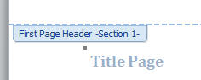
3. Click on the Close Header and Footer button.
4. Save this document.
5. Go to the next page (section). Note that the header (not on Section 1) shows in Section 2 (and 3).
6. Double-click in the header and note that the designation there is "Header -Section 2-"
7. On the right side it still says "Same as Previous." If you were to select different First Page for this section as well, it would give you the same First Page Header as the previous section (blank).

**Different Odd and Even**

The Different Odd and Even option allows you to format your headers and footers differently. For example, you may want the page numbers on the odd pages to be aligned to the right and the page numbers on the even pages to be aligned to the left when you are printing double sided documents. This option is just under the Different First Page option.

**Link to Previous**

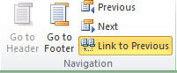

Word's default is to connect all the Headers in the document and all the footers in the document so they are all the same. It does this by using the Link to Previous command. It is important to turn OFF the Link to Previous option FIRST before you make any other changes. This will prevent the previous section from being changed as well.

|  |  |
| --- | --- |
| Tip | **Tip**  It is usually better to start at the top of your document when working with Headers and Footers. |

How many Sections do you need? If you are inserting a section break just to change the text in your header / footer, look into use of the [StyleRef field](http://www.addbalance.com/usersguide/fields.htm" \l "STYLEREF" \o "Headers Footers Microsoft Word Sections StyleRef field" \t "_blank) with Word's built-in heading styles. This lets you change the content of your header / footer without making any change in the header / footer. The StyleRef field can reflect the content  of the latest heading or other style and change each time you format something new with that Style.

**Note** each section in Word can have up to *three* headers and three footers. The choices of different first page, different odd and even apply to both headers and footers for each section. The setting for link with previous is *independent* for each of these, that is, the first page header can be linked to previous while the first-page footer is not and neither setting has any effect on the settings for the odd or even page headers and footers.

**Page Numbers in Word 2007-2010**

Page numbers are relatively simple, but the interface can make them seem complicated. *Page numbers in Word are always fields.* We will start by looking at how to insert them through the Interface's Insert Page Number functions and then look at how they can be inserted and formatted directly.

Word comes with a number of built-in formats that are stored in building blocks.

You can easily add a page number to your document under the Insert tab. Click on the Page Number button and you'll get a short menu giving a choice of positions as well as the option to format or remove page numbers. If you select one of the positions, you'll get a gallery view of your options (below). Note that this gallery has a scroll bar. *(Don't see a gallery?)*

Note that all of the positions except Current Position put the page number in the current header or footer replacing that header/footer.*This includes the numbers in the page margins*.

**Warning**about Page Number Insertion

*Repeat: Inserting page numbers using the gallery will replace current headers or footers*.

If you already have a header or footer and want a page number go into the header / footer edit mode and insert a page number at the current position. This will not replace the header / footer.

**Fields**

Again, page numbers are fields. This is true no matter how you insert them. If you select a page number and press Shift-F9 to 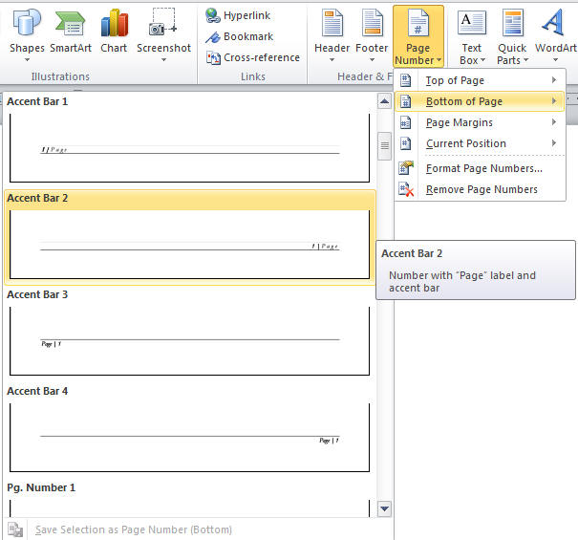toggle field codes, you will see **{** PAGE **}**,  a very simple field code. If you ever need to insert this manually you can do so

through the Insert Field dialog. You can access this by pressing Ctrl-Alt-F9 or under the Insert tab > Quick Parts > Field.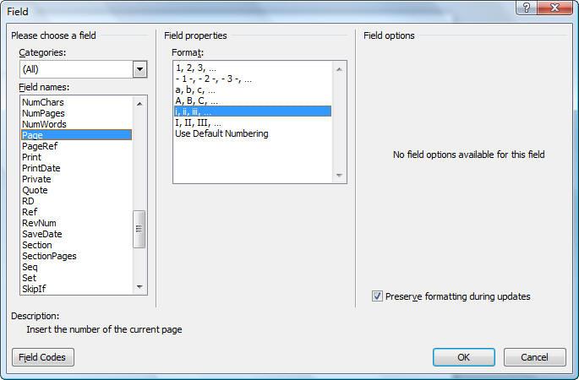

The Insert Field dialog box is shown at the right. Using the choices shown will result in a lower case Roman numeral page number in the current formatting. The field would look like this:   
**{** PAGE  \\* roman  \\* MERGEFORMAT  **}**

You do not have to choose the page type when you insert the page number but it is easiest to do so.

Other useful fields are the Numpages and Secpages fields which give the total number of pages in the document and Section respectively.

**Format Page Numbers**

You will need to understand how to format page numbers. For example, you may add a Table of Contents to your document and would like the page numbering of the front matter before the body of your document to be in lowercase Roman numeral format. As long as your document is divided into sections, you can have differently formatted page numbers in each section of your document.

**EXERCISE 5: Format Page Numbers**

Create a new blank document.

Save As (your initials) Sections. (i.e. "ckk Sections.docx" becomes the document name)

1. Type

**Confidential Employment Agreement**   
**ZZZ Company**   
**January 1, 2012**

1. Choose Page Layout(tab) > Breaks. From the Section Breaks area, select Next Page to insert a Next Page section break.
2. Type **Table of Contents**and press ENTER.
3. Insert a Next Page section break.
4. From the Style drop-down list on the Formatting toolbar, choose Body Text.
5. Type **=rand(30)** and press ENTER.
6. Insert a Next Page section break.
7. Type **Appendix: Salary Increases**and press ENTER.
8. Still on the Page Layout tab choose Orientation and select Landscape.
9. Save the document.
10. Press CTRL+HOME to get the top of the document.
11. Click on the Insert tab. (What follows is manual method 1 to insert a page number)
12. Click on the Footer button and choose Edit Footer. Your cursor should be in the footer of the first page.
13. Notice that it says: Footer Section 1. We do not want a page number on the first page so leave it blank.
14. Click the Show Next button to jump to the next footer. It should read: Footer Section 2
15. Notice on the right that it says Same As Previous.
16. Click the Link to Previous button in the Ribbon. This disconnects Section 2 footer from Section 1 footer.
17. On the Page Number button select Format Page Number. The Page Number Format dialog box opens.

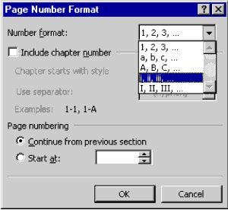

1. From the Number format drop-down list, choose lowercase Roman Numerals.
2. Under Page Numbering, select Start at to have the page numbers start counting from this section.
3. Click OK to return to the footer.
4. Click the On the Page Number choose current position.
5. Press your left arrow key once to move in front of the page number.
6. Press the tab key to move the number to the middle of the footer (By default, there is a Center tab set in the footer style.)
7. Go back to Edit Footer under Footer button
8. Click the Show Next button to jump to the next footer. It should read: Footer Section 3.
9. Turn off Same As Previous using the Link to Previous button on the Header/Footer Tools ribbon.
10. Click Page Number Format under the Page Number button.
11. The number format should already be Arabic numerals; choose Start At and change the Start At to 1. Click OK.
12. Click Show Next to move the cursor to Footer-Section 4.
13. Turn off Same As Previous.
14. Change the number format to capital letters.
15. Click Close on the Header/Footer Tools Ribbon.
16. Switch to Print Layout and make sure your page numbers are correct.

**Columns (CK Section)**

Columns are a creature of sections, like headers and footers. The command to set them up is found under the Page Layout tab.

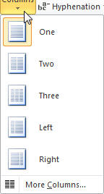

More Columns... gives you a dialog box which gives you even more control.

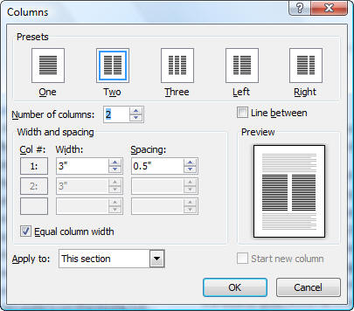

Apply to - columns Microsoft Word - SectionsThe "Apply to:" choice of "This point forward" allows you to insert a continuous section break where you are and make the rest of the current section have the column settings you want. The default is "This section." Another choice is to have the column layout apply to the entire document. The Start new column checkbox is one way to insert a column break before the bottom of the page. If you select the Left or Right column preset it unchecks the Equal column width setting. Line between inserts a vertical line between columns.

You can set the number of columns to a larger number if you want. Note though that more than 3 columns is not practical on a portrait layout letter-size page. Unchecking the Equal column width setting lets you manually change your column width. The spacing between columns is preset at 0.5." Adjusting this is a way to get all of your text on one page or fill out a page.

**EXERCISE 6: Change Formatting to Columns**

1. Open the document with three sections from the Header/Footer Exercises.
2. Press Ctrl-End to go to the end of the document.
3. Press the ENTER after the Heading "Main Document"
4. Type **=rand(30, 4)** and press ENTER.
5. Go back to the point just under the heading.
6. Under the Page Layout tab, click on the Columns button and select the option for two columns.
7. Notice that if you were in Draft view you are now in Print Layout view.
8. Notice that your heading is inside the columns.
9. Press Ctrl-Z to undo the column formatting.
10. Click on the Columns button and this time select "More Columns..." to bring up the dialog box.
11. Select the two column preset and under "Apply to" select "This Point Forward."
12. Click OK.
13. Notice that your Heading is now outside the Column formatting. You have just created a new (continuous) section break.
14. Try clicking the option to have three columns instead of two under the Columns button. Note that it applies to the current section.
15. Click in the middle of the page in the middle of a paragraph.
16. Reopen the Columns dialog box by selecting "More Columns..." under the Columns button.
17. Select the two column preset and under "Apply to" select "This Point Forward."
18. Click OK.
19. Note that you now have a three column section followed by a two column section.
20. Note that the section break was inserted in the middle of your paragraph, even in the middle of a sentence!

The Column set up in Word is the equivalent to "Snaking columns" in Word Perfect. To get parallel columns in Word you would use Tables.

**Complex Document Overview**

Complex documents in a legal environment are plentiful, and generally these documents are to be filed or sent to clients on a time sensitive basis. That's why knowing the ins and outs of the tools that Word has to offer in the quick creation of Tables of Contents, Tables of Authorities, Indices, cross-references (and more) is essential in the timely completion of these documents.

Note: A key to drafting and editing complex documents in Word is using [Styles](http://www.addbalance.com/usersguide/styles.htm) in your formatting, especially the [built-in heading styles](http://www.shaunakelly.com/word/numbering/usebuiltinheadingstyles.html).

**Quick Navigation Using****Document Map**

When you use styles in your complex document Microsoft Word's Document Map feature lets you quickly move to different headings within a document. This is a real time-saver when working with long documents.

The Document Map is just like a road map. If you have used heading styles within your complex document you can maneuver your way through the document by clicking on the corresponding heading that you need to access for editing. By clicking the heading, you are transported to that destination in your document. So, if you had a document that was 42 pages long, and you needed to get to heading 6.2 on page 31, just click on the heading in the Document Map area and you quickly move to this location.

Warning - The Document Map has known bugs that can corrupt your document if you use it to reorganize. This was fixed with the [Navigation Pane in Word 2010](http://www.addbalance.com/word/navigation2010.htm).

**EXERCISE 7: Navigate Using Document Map**

1. Create or open a long document formatted with heading styles.
2. Click the Document Map button on the Standard toolbar, or from the View menu, choose Document Map.
3. Click on a heading within the document map to move to that section in the document.
4. Click on a different heading in the document map to move to another section within the document.

To turn off the document map feature, click the Document Map button on the Standard toolbar. The button works as a toggle.

**Generating a****Table of Contents**

When you use Word's built-in styles or your own custom styles within your long document, generating a table of contents can be as easy as 1-2-3. Word will do all the work for you by inserting your applied headings (at their different levels) into a quickly generated table of contents. You can also customize your indents, tab leaders, page numbers, and even other formatting for your table of contents easily in the creation process of your TOC.

You are not restricted to using just the heading styles method of creating a table of contents, you can mark your headings manually, or you can define what styles the table of contents includes by selecting any styles from within the document.

**EXERCISE 8: Generate a Table of Contents Using Applied Styles**

1. Create a new document and type the following text:   
   **Introduction**   
   **Overview**   
   **Unsolicited Proposals**   
   **Solicited Proposals**   
   **General**   
   **The Proposal**
2. Click anywhere within the first line, Introduction.
3. Click the Style drop-down arrow and apply Heading 1.

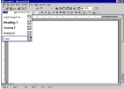

|  |  |
| --- | --- |
| Note | **Note**  In Word 97, finding your style in the Style drop-down list can be a bit confusing. The styles are not listed in alphabetical order. In Word 2000 the styles are listed alphabetically. |

1. Select Overview, and apply Heading 2.
2. Select Unsolicited Proposals, Solicited Proposals and General. Apply Heading 3.
3. Select The Proposal and apply Heading 2 style and after deselecting the text, press Enter twice.
4. From the Insert menu, choose Index and Tables. Select the Table of Contents tab.

Word 97 Table of Contents Tab:

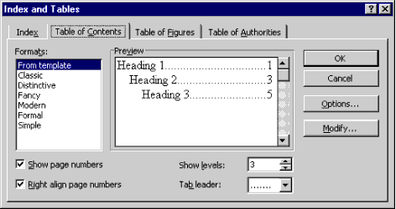

Word 2000-Word 2010 Table of Contents Tab:

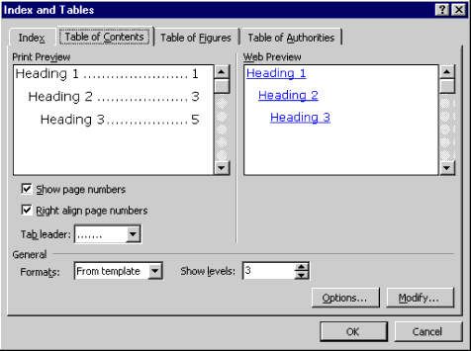

As you see from the two previous figures, the only difference between Word 97 and Word 2000's Table of Contents tabs is that Word 2000 allows you to preview your table of contents, as it will look on the web, not with page numbers, but with your headings as hyperlinks.

|  |  |
| --- | --- |
| Note | **Note** On the Table of Contents tab in the Index and Tables dialog box, Word provides you with the default format "From Template," and lists other options under the Formats box. By clicking on the other available formats within the format area notice how the preview of the table of contents change, as well as the available options below the Formats and Preview sections in the dialog box based on the format selected.  **Note:** Word 2007/2010 Insert TOC is through the References Tab. |

1. Accept the "From Template" default. Click OK and your table of contents is generated.

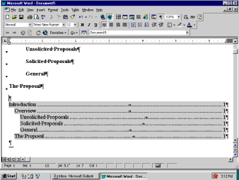

**EXERCISE9: Generate a Table of Contents By****Manually Marking Entries**

1. Create a new document and again type the following text:   
   **Introduction**   
   **Overview**   
   **Unsolicited Proposals**   
   **Solicited Proposals**   
   **General**   
   **The Proposal**
2. Select the first line Introduction.
3. Press ALT+SHIFT+O on the keyboard. This combination opens the Mark Table of Contents Entry dialog box. (Notice that your selected text is in the Entry field.)

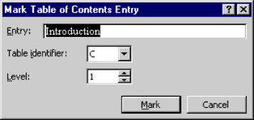

1. The Table Identifier default is C if you do not have any other tables (Table of Figures, Table of Authorities, etc.) within your document. This is for multiple tables and allows for hierarchy among the tables.

The next field is the Level identifier for your selected text. You change this field to correspond to whatever heading levels you have selected.

1. Click Mark, and your TOC entry has been marked for insertion to your table of contents. The Mark Table of Contents Entry dialog box will stay open so that you can click twice back into your document and select the next heading without closing the dialog box.
2. Select the next heading, and then click twice back into the dialog box, and the newly selected heading will automatically be placed in the Entry field.
3. Mark all of the headings in your document with the appropriate levels.
4. Place the insertion point where you want the table of contents to be generated. From the Insert menu, choose Index and Tables. Select the Table of Contents tab.
5. Click Options.

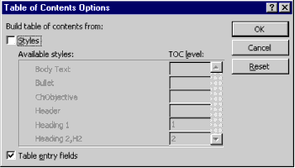

1. Under the option for Build table of contents from, uncheck the Styles checkbox and check the option for Table entry fields. Click OK, and then OK again to close the dialog box and to generate your manually marked table of contents.

|  |  |
| --- | --- |
| Note | [**CK Note**](http://www.addbalance.com/usersguide/supplement.htm#CKNotes)**:**Manually inserting a Table of Contents Entry inserts a TC field in your document. For more on this field, see the Microsoft Support [page](http://support.microsoft.com/support/word/usage/fields/tc.asp) on it. |

**Updating a Table of Contents**

As with all complex documents, edits are constantly occurring. These edits will ultimately affect your initially generated table of contents. There are various ways to update the table of contents:

|  |  |
| --- | --- |
| **METHOD** | **ACTION** |
| ***Shortcut menu (Alternate-click)*** | Click anywhere in the table of contents and select Update Field |
| ***F9*** | Click anywhere in the table of contents and press F9 |
| ***Select Text+F9*** | Only updates selection. This works well when you have other fields in the document |
| ***Tools, Options, Print tab, Update Fields*** | This allows the document to update all fields whenever you print the document |

When you decide to update your table of contents and use one of the options listed previously, the Update Table of Contents dialog box appears.

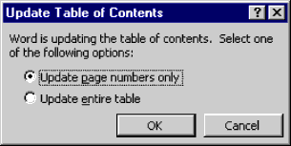

You are asked whether you want to Update page numbers only, or if you would like to Update entire table. If you have manually changed any text in the table of contents and only want the page numbers to be updated, select that option.